1. FB50 – CPF&GPF Accounting
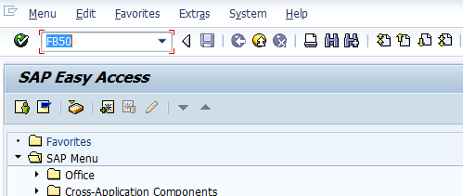
- Input FB50 in Transaction box and press Enter key

1.1 Document Header Data Information
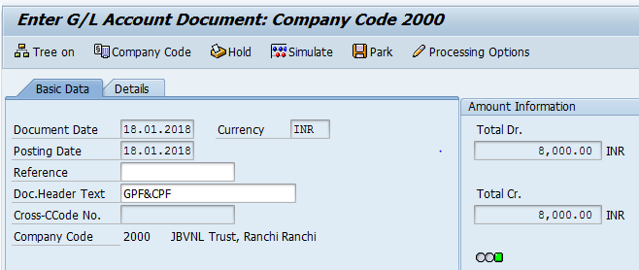
The following are the Input fields under the Document Header data
- Document Date: Input the Invoice date in the Document date field
- Posting Date: Input the transaction date in the Posting date field
- Currency: Input the Currency INR in the Currency field
- Document Header Text: Input the Text Information in text field

1.2 Document Line Item Data
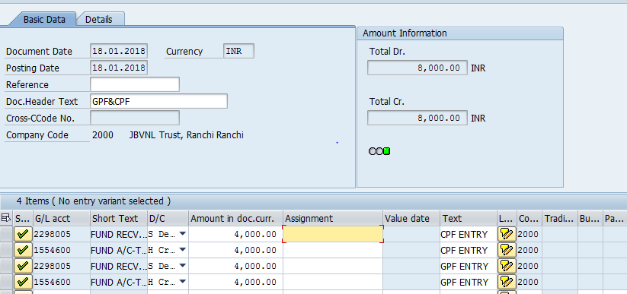
The following are the Input fields under the Line Item data
- GL Account: Place the Cursor on the field and press F4. Select the respective GL Account and press Enter key
- Debit/Credit: Select Debit/Credit option from drop down list
- Text Field: Input the Text information
- Profit Center: Place the cursor on the field and press F4. Select the respective Profit Center and press Enter key

1.3 Simulate
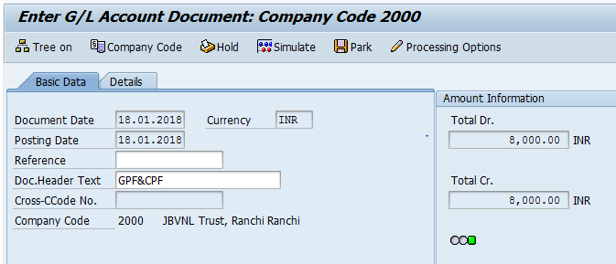
Simulate: Click on Simulate option. System will display the line items (Debit and Credit entry).
- Check the entries, if the entries are correct, click on Post option
- If the entries are wrong then go to Main screen and change the line items.
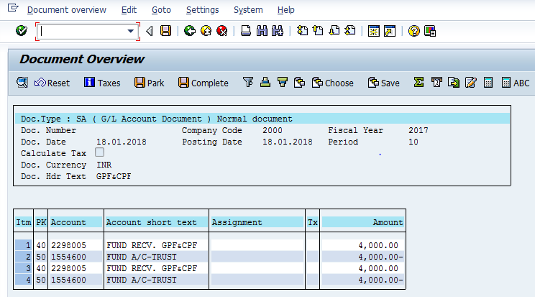

1.4 Document Posting
- Document Posted in company code 2000 will pop up at the bottom of the screen

1.5 Document Display View
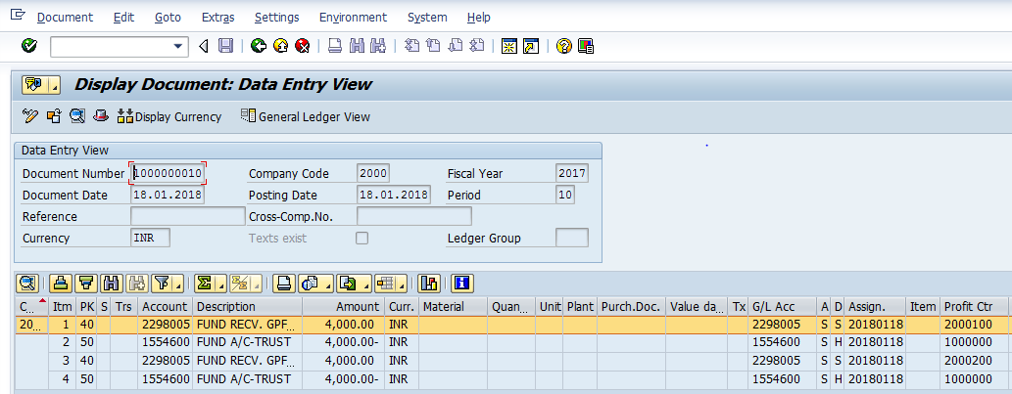
- Display Document: From Menu bar select Document option it will display the options Change, Display, Post and Save as completed. Choose Display option. Document successfully got posted will get displayed or It can be displayed in TC FB03.

2. Payment to the Trust Company

2.1 Document Header Data Information
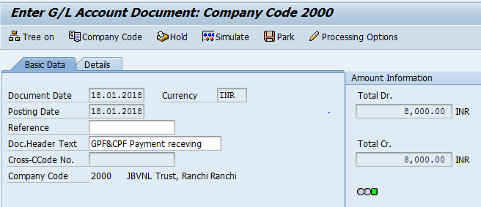
The following are the Input fields under the Document Header data
- Document Date: Input the Invoice date in the Document date field
- Posting Date: Input the transaction date in the Posting date field
- Currency: Input the Currency INR in the Currency field
- Document Header Text: Input the Text Information in text field

2.2 Document Line Item Data
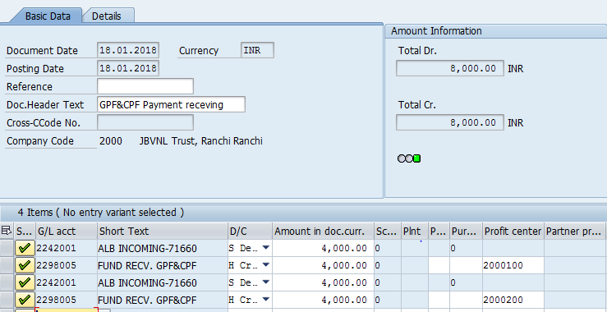
The following are the Input fields under the Line Item data
- GL Account: Place the Cursor on the field and press F4. Select the respective GL Account and press Enter key
- Debit/Credit: Select Debit/Credit option from drop down list
- Text Field: Input the Text information Eg: Payment to Trust
- Profit Center: Place the cursor on the field and press F4. Select the respective Profit Center and press Enter key

2.3 Simulate
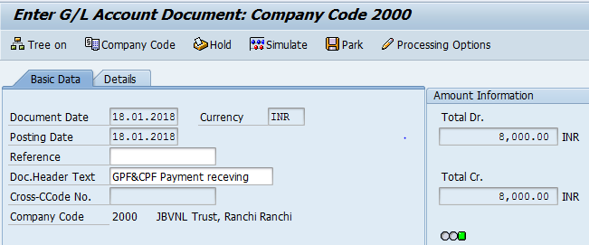
Simulate: Click on Simulate option. System will display the line items (Debit and Credit entry).
- Check the entries, if the entries are correct, click on Post option
- If the entries are wrong then go to Main screen and change the line items.
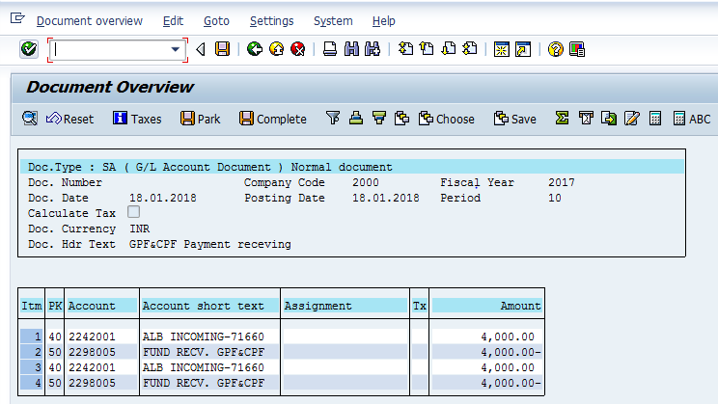

2.4 Document Posting
- Document Posted in company code 1000 will pop up at the bottom of the screen

2.5 Document Display View
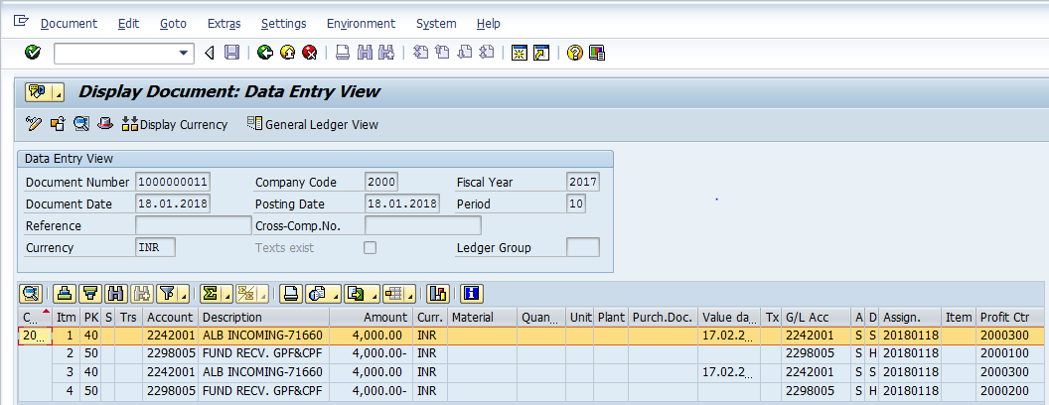
- Display Document: From Menu bar select Document option it will display the options Change, Display, Post and Save as completed. Choose Display option. Document successfully got posted will get displayed or It can be displayed in TC FB03.

3.1 FB60 – Employee Vendor Invoice Booking
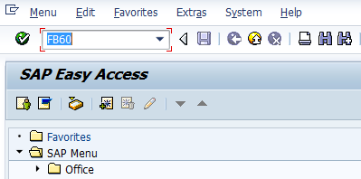
- Input FB60 in Transaction box and press Enter key

Document Header Data Information
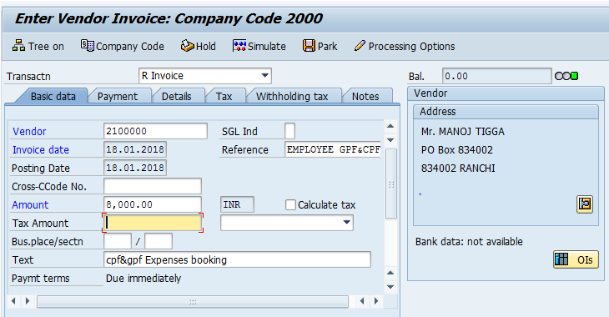
The following are the Input fields under the Document Header data of Vendor Invoice
- Vendor: Input the Vendor Number in the Vendor field with help of press “F4” button to search vendor number.
- Invoice Date: Input the Invoice date in the field
- Posting Date: Input the transaction date in the Posting date field
- Currency: Input the Currency INR in the Currency field
- Reference: Input the Reference field with Reference (invoice) number
- Text: Input the Text Information in text field Eg: Vendor invoice posting with Tax

Document Line Item Data
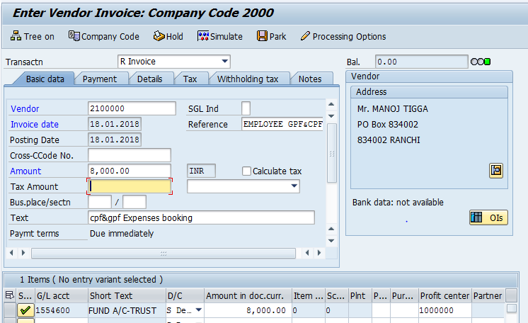
The following are the Input fields under the Line Item data to be filled.
- GL Account: Place the Cursor on the field and press F4. Select the respective GL Account and press Enter key
- Debit/Credit: Select Debit/Credit option from drop down list
- Text Field: Input the Text information e. g.: Vendor Invoice posting with Tax
- Profit Center: Profit Center will get automatically updated (through Cost Center Profit Center will get updated) as configured.

Simulation of Transaction before posting:
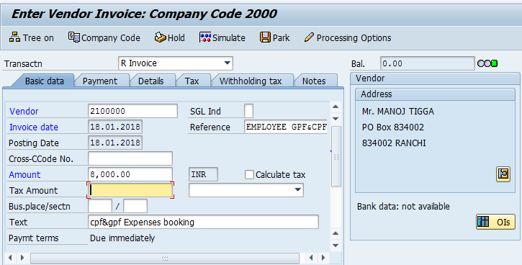
Simulate: Click on Simulate option. System will display the line items (Debit and Credit entry).
- Check the entries, if the entries are correct, click to Post Button
- If the entries are not okay, then go to main screen and take required action to correct it.
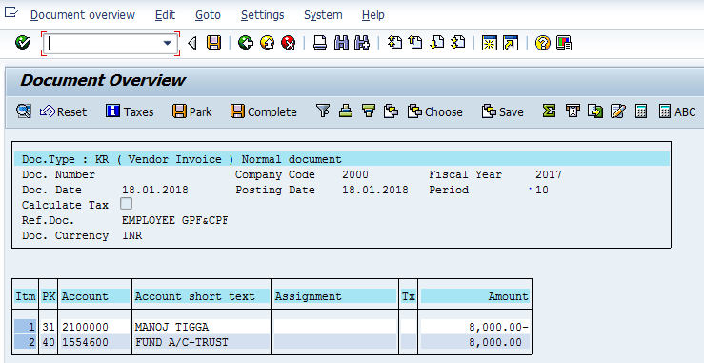
Click on Save icon

Document Posting
- Document is posted, An information will be populated at the bottom of the screen

Document Display View
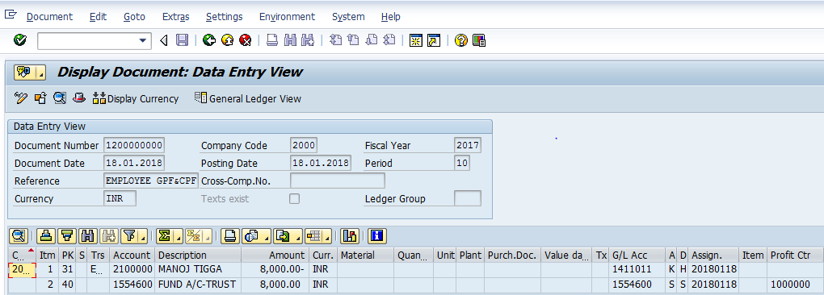
We can view the transaction in two ways:
- Display Document: From Menu bar select Document option it will display the options Change, Display, Post and Save as completed. Choose Display option. Document successfully got posted will get displayed
- Input FB03 in Transaction box and system will take us to Document Display screen. Input the Document number and Press Enter key. Document posted will get displayed.

F-53 : Employee Vendor Outgoing Payment
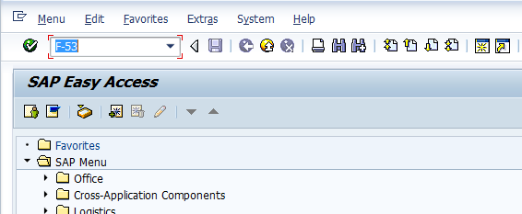
- Input F-53 in Transaction box and press Enter key

Employee Vendor Outgoing Payment
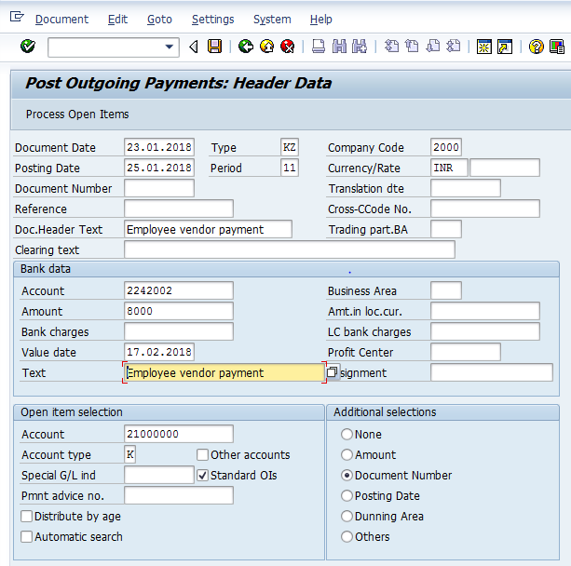
The following are the Input fields under the Document Header data of Vendor Outgoing Payment
- Document Date: Input the Invoice date in the field
- Posting Date: Input the transaction date in the Posting date field
- Document Type: Input the Document type KZ for Vendor payment
- Company Code: Input the Company code 1000 in this field
- Currency: Input the Currency INR in the Currency field
- Reference: Input the Reference field with Reference (invoice) number
- Clearing Text: Input the text information in this field
Bank Data: Under this Section
- Account: Place the cursor on the field and press F4. List of GL Accounts will appear, select respective Bank outgoing GL Account and press Enter key
- Amount: Input the amount
- Profit Center: Input the respective Profit center by selecting from the drop down list
- Text: Input the text information in this field
Open Item Selection: Under the section
- Account: Input the Vendor Number in this field
- Account Type: Input the Account type “K” (Vendors) from drop down list
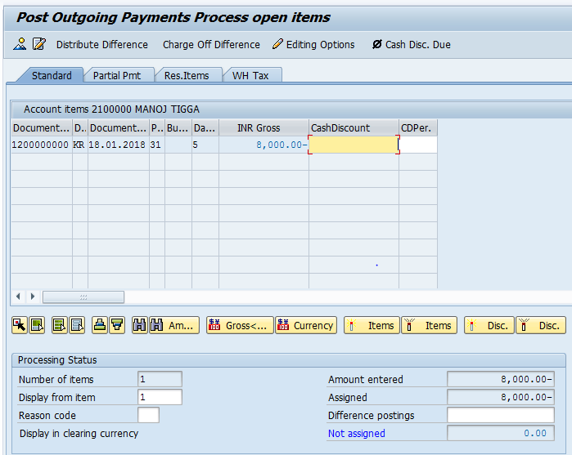
- Select All items Icon and select Deactivate items tab
- Double Click on the line items(Debit and Credit) which will get activated(turns in to Blue colour)
- Select Document option in Menu, choose Simulate option.

Simulation of Transaction before posting:
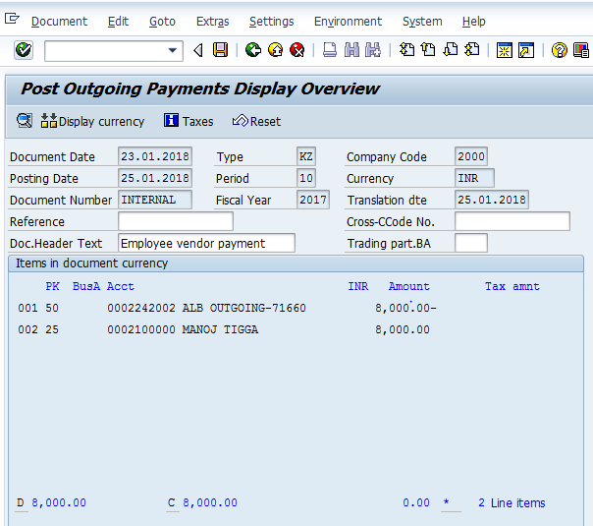
Simulate: Click on Simulate option. System will display the line items (Debit and Credit entry).
- Check the entries, if the entries are correct, click to Post Button
- If the entries are not okay, then go to Main screen and take required action to correct it.

Document Posting
- Document is posted, An information will be populated at the bottom of the screen

Document Display View
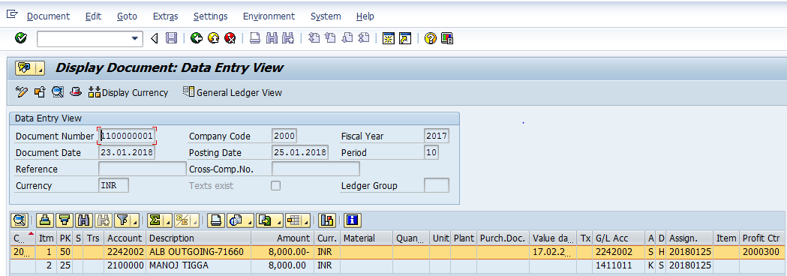
We can view the transaction in two ways:
- Display Document: From Menu bar select Document option it will display the options Change, Display, Post and Save as completed. Choose Display option. Document successfully got posted will get displayed
- Input FB03 in Transaction box and system will take us to Document Display screen. Input the Document number and Press Enter key. Document posted will get displayed.

Manual End

